**AUTOMATED PLANT WATERING SYSTEMS**

**By team** “Aqua rangers”

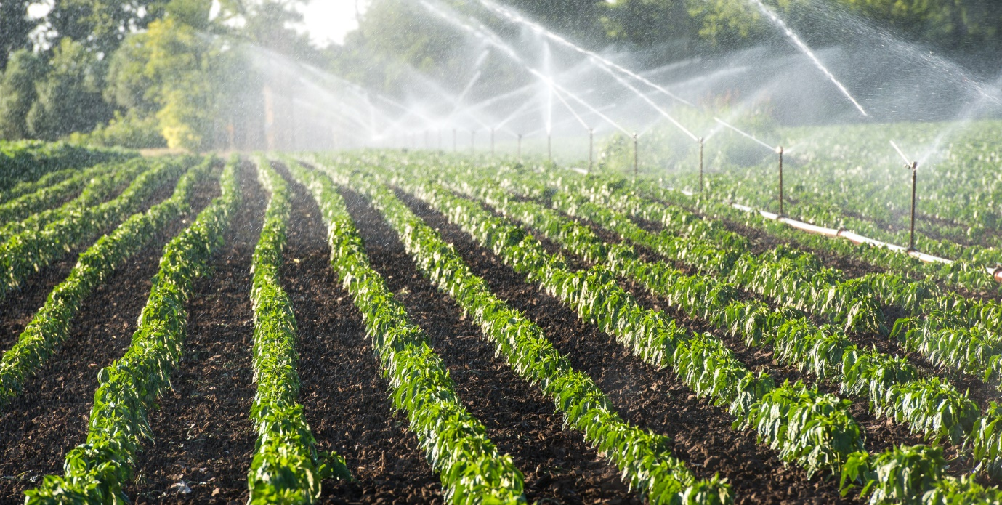

Figure1:-An example of automated plant watering systems.

**Team details:**

**Radesh.M(2023000565)**

**Mallikarjun.M (2023000729)**

**Rohan Aditya.O(2023000774)**

**Gautham Aditya.M(2023000791)**

**Aim:-**

Automated plant watering systems aim to provide consistent and efficient watering, promoting plant health. They help conserve water, save time, and prevent over/underwatering by automating the watering process based on soil moisture or schedules.

**Objectives:**

1.Resource Conservation: Efficiently utilize water resources by avoiding overwatering and minimizing water wastage, contributing to environmental sustainability.

2. *Time Efficiency: Streamline the watering process, saving time for gardeners and enabling them to manage larger or multiple plant areas more effectively.

3. *Optimal Plant Health: Foster healthier plant growth by maintaining consistent moisture levels, reducing the risk of diseases and stress caused by fluctuations in watering.

. *Customization and Flexibility: Allow users to tailor watering schedules to specific plant needs, adapting to changing seasons or variations in environmental conditions.

**THEORY,CONCEPTS AND IDEATION:**

THEORY:

The automatic plant watering system using blynk is an existing system that uses a sensor to detect the soil moisture levels and triggers an Water planting system to water the plants when the soil moisture level falls below a certain threshold. The system typically consists of the following components:

1.Bylink sensor: The sensor is placed in the soil to detect the moisture level of the soil. 2.Microcontroller: The microcontroller is responsible for reading the moisture level data from the bilink sensor and controlling the irrigation system based on the data.

3.Water pump: The water pump is used to deliver water to the plants when the moisture level falls below the threshold.

4.Solenoid valve: The solenoid valve controls the flow of water from the water source to the Water planting system.

5.Power supply: The system requires a power supply to operate, which can be a battery or a power adapter. The existing system has several advantages over manual watering methods, including improved plant growth, reduced water usage, and reduced labour costs. The system is also easy to install and operate, making it an attractive option for both small-scale farmers and home gardeners. However, there are some limitations to the existing system. The accuracy of the bilink sensor may vary depending on the type of soil and environmental factors such as temperature and humidity. The system may also require periodic calibration to ensure accurate readings. Overall, the existing automatic plant watering system using bilink is a promising technology that can help improve the efficiency and sustainability of agriculture and gardening practices. With continued development and improvement, the system has the potential to revolutionize the way we water our efficiency and sustainability of agriculture and gardening practices. With continued development and improvement, the system has the potential to revolutionize the way we water our plants.

**CONCEPTS:**

Currently we have the following concepts in mind:

->Internet of technology

->Moisture monitor

->Arudino microcontroller

**OUR CONTRIBUTION AND IDEAS:**

->We aim to make all the existing implementations more accessible

->Try to implement sensors technology in agriculture sector as well

->Apply these technologies to the machines as well

->An easy to use mobile application and also to control the manpower

->An made in India project which makes an better profit to the nation

**ANALYSIS AND FINDINGS:**

Simulation resuls:

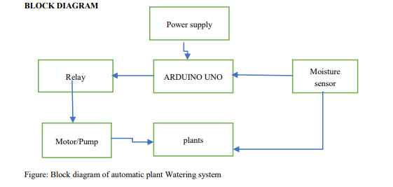

**Arduino Uno Board:** Arduino is an open source electronics electronic platform based on easy to use hardware and software .Arduino boards are abile to read inputs of sensor,a finger on a button and turns into an output activating on a motor ,turning on an LED ,publishing something online.now a daysarduino is the brain of thousands of projects.aworldwise community of markers has gathered around this open source platform, their contributions have add to up an incredible amount of accessible knowledge that can be great help to novice and experts

**Soil Moisture sensor:** The Soil moisture is the primary part of this project.Soil moisture sensors measure the water content in the soil and can be used to estimate the amount of stored water in the soil horizon.Soil moisture sensore do not measure water in soil directly. Instead,they measure changes in some other soil property that is related to water content in a predictable way

**Water pump**: The water pump is utilized to give water to work.As required, it can be started ON/OFF by the transmitting signals. A 12 voltage dc motor is used with the pump. By activating the motor driver circuit by the read value of the Arduino board with the set reference value, the pump will automatically turn on and turn off.

**Relay Module:** Relay board module is used for controlling higher current loads from microcontroller development board, PC parallel or arduinouno. This board has one onboard relay which can switch upto 7 amps. Relays terminals (C,NC,NO) are accessible through screw terminals which makes wiring up the board very easy. The relay is safely driven by transistor BC547 hence input device, such as arduino, is protected from realy circuit. There is free wheeling diode which will further protect microcontroller from relay kick back

***BLYNK APP We can install Blynk app setup.Blynk App is an IOT platform for iOS or Android smartphones that is used to control the Arduino .This application is used to create a graphical interface or human machine interface by compiling and providing the appropriate address on the available widgets***

**RECOMMENDATIONS&SUGGESTIONS**

1.Water savings: The amount of water savings will depend on the amount of water used for manual watering and the efficiency of the automatic system. For example, suppose you have a garden with ten plants that require 4 liters of water per day. Manual watering would require 38 liters of water per day. With the automatic system, if the blynk sensor detects that the soil moisture level is adequate and only waters the plants when necessary, it may use only for 19 liters of water per day, resulting in a daily water savings of 19 liters.

2.Labor savings: The amount of labor savings will depend on the size of the garden or farm and the frequency of watering. For example, suppose it takes one hour per day to water a garden manually, and the automatic system eliminates the need for manual watering. In that case, the system can save one hour of labor per day.

3.Fertilizer savings: The amount of fertilizer savings will depend on the type of plants, the soil quality, and the frequency of watering. By ensuring that the plants receive the optimal amount of water, the system can reduce the need for fertilizers. Suppose you use 1000 Rupees of fertilizer per week for manual watering. In that case, the automatic system may reduce the need for fertilizers by 25% or 250 Rupeesper week, resulting in weekly fertilizer savings of 250 Rupees.

4.Improved plant growth: The value of improved plant growth can vary depending on the type of plants, the yield of crops, and the property value of the garden or farm. Improved plant growth can lead to higher crop yields, which can increase revenue for farmers, or increased property value for homeowners. Overall, the savings of an automatic plant watering system by using blynk will depend on several factors, including water usage, labor costs, fertilizer usage, and plant growth. By calculating these factors, you can estimate the potential savings of the system and determine if it is a cost-effective investment for your garden or farm.

**CONCLUSION:**

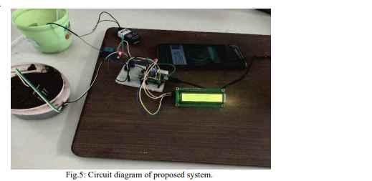

Automatic system using a microcontroller, moisture sensor and other electronic tools were been developed. It was observed that the proposed methodology controls the moisture content of the soil of cultivated land. The motor automatically start pumping water if the soil is dry and need water and stops when the moisture content of the soil is maintained as required.